**SHAHJALAL UNIVERSITY OF SCIENCE & TECHNOLOGY, SYLHET**



**Department Of Computer Science and Engineering**

**Electronics Circuit 1 Lab Report**

**Course : EEE-110**

**Submitted to :**

**Jibesh Kanti Saha**

**Lecturer, Department of EEE, SUST**

**Submitted by :**

**Name: Md. Shamihul Islam Khan**

**Reg. No: 2016331078**



**Department Of Computer Science & Engineering**

**Electronics Circuit 1 Lab Report**

**Experiment No: 01**

**Experiment Name: Ohm’s Law**

**Course Code: EEE-110**

**Date of Performance : 13-09-17**

**Date of Submission : 08-10-17**

**OBJECTIVE**

This exercise examines Ohm’s law, one of the fundamental laws governing electrical circuits. It states that voltage is equal to the product of current times resistance.

**THEORY OVERVIEW**

Ohm’s law is commonly written as V = I * R. That is, for a given current, an increase in resistance will result in a greater voltage. Alternately, for a given voltage, an increase in resistance will produce a decrease in current. As this is a first order linear equation, plotting current versus voltage for a fixed resistance will yield a straight line. The slope of this line is the conductance, and conductance is the reciprocal of resistance. Therefore, for a high resistance, the plot line will appear closer to the horizontal while a lower resistance will produce a more vertical plot line.

**EQUIPMENT**

1. Adjustable DC Power Supply
2. Digital Multimeter
3. 550Ω resistor

**SCHEMATIC**

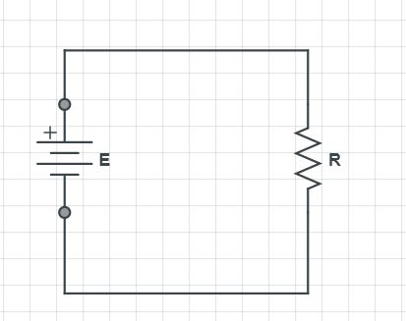

Figure 1

**PROCEDURE**

1. Build the circuit of Figure 1 using the 550 Ω resistor. Set the DMM to measure DC current and insert it in-line between the source and resistor. Set the source for zero volts. Measure and record the current in Table 1. Note that the theoretical current is 0 and any measured value other than 0 would produce an undefined percent deviation.

2. Setting E at 2 volts, determine the theoretical current based on Ohm’s law and record this in Table 1. Measure the actual current, determine the deviation, and record these in Table 1. Note that Deviation = 100 * (measured – theory) / theory.

3. Repeat step 2 for the remaining source voltages in Table 1.

4. Using the measured currents from Tables 1 create a plot of current versus voltage. Plot all three curves on the same graph. Voltage is the horizontal axis and current is the vertical axis.

**DATA TABLES**

|  |  |  |  |  |
| --- | --- | --- | --- | --- |
| **E (Volts)** | **V(Volts)** | **I theory (mA)** | **I Measured (mA)** | **Deviation** |
| 5 | 6.64 | 0.012 | 0.012 | 0 |
| 6 | 9.26 | 0.0168 | 0.016 | 0 |
| 8 | 10.94 | 0.0198 | 0.019 | 0 |
| 10 | 12.18 | 0.022 | 0.022 | 0 |
| 12 | 13.59 | 0.024 | 0.024 | 0 |

Table 1

Plot of Current Vs Voltage across the load resistor :

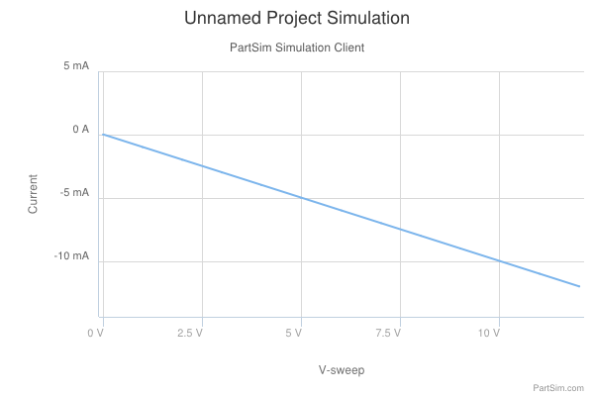

Figure : Current vs Voltage Graph



**Department Of Computer Science & Engineering**

**Electronics Circuit 1 Lab Report**

**Experiment No: 02**

**Experiment Name: Series-Parallel Circuit**

**Course Code: EEE-110**

**Date of Performance : 13-09-17**

**Date of Submission : 08-10-17**

**OBJECTIVE**

The focus of this exercise is an examination of basic parallel DC circuits with resistors. A key element is Kirchhoff’s Current Law which states that the sum of currents entering a node must equal the sum of the currents exiting that node. The current divider rule will also be investigated.

**THEORY OVERVIEW**

A parallel circuit is defined by the fact that all components share two common nodes. The voltage is the same across all components and will equal the applied source voltage. The total supplied current may be found by dividing the voltage source by the equivalent parallel resistance. It may also be found by summing the currents in all of the branches. The current through any resistor branch may be found by dividing the source voltage by the resistor value. Consequently, the currents in a parallel circuit are inversely proportional to the associated resistances. An alternate technique to find a particular current is the current divider rule. For a two resistor circuit this states that the current through one resistor is equal to the total current times the ratio of the other resistor to the total resistance.

**EQUIPMENT**

1. Adjustable DC Power Supply
2. Digital Multimeter
3. 1 kΩ
4. 550 Ω
5. 320 Ω

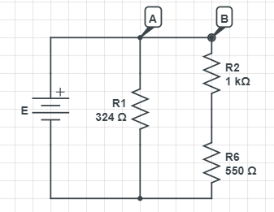**SCHEMATICS**

Figure 1

**PROCEDURE**

1. Using the circuit of Figure 1, determine the theoretical voltages at points A, B, and C with respect to ground. Record these values in Table 1. Construct the circuit. Set the DMM to read DC voltage and apply it to the circuit from point A to ground. The red lead should be placed at point A and the black lead should be connected to ground. Record this voltage in Table 1. Repeat the measurements at points B and C.

2. Apply Ohm’s law to determine the expected currents through R1 and R2. Record these values in the Theory column of Table 2. Also determine and record the total current.

3. Set the DMM to measure DC current. Remember, current is measured at a single point and requires the meter to be inserted in-line. To measure the total supplied current place the DMM between points A and B. The red lead should be placed closer to the positive source terminal. Record this value in Table 2. Repeat this process for the currents through R1 and R2. Determine the percent deviation between theoretical and measured for each of the currents and record these in the final column of Table 2.

4. Crosscheck the theoretical results by computing the two resistor currents through the current divider rule. Record these in Table 3.

5. Consider the circuit of Figure. Using the Ohm’s law, determine the currents through each of the four resistors and record the values in Table 4 under the Theory column. Note that the larger the resistor, the smaller the current should be. Also determine and record the total supplied current and the current IX. Note that this current should equal the sum of the currents through R3 and R4.

6. Construct the circuit of Figure. Set the DMM to measure DC current. Place the DMM probes in-line with R1 and measure its current. Record this value in Table 4. Also determine the deviation. Repeat this process for the remaining three resistors. Also measure the total current supplied by the source by inserting the ammeter between points A and B.

7. To find IX, insert the ammeter at point X with the black probe closer to R3. Record this value in Table 4 with deviation.

**DATA TABLES**

|  |  |  |  |  |  |  |
| --- | --- | --- | --- | --- | --- | --- |
| **E** | **IA** | | **IB** | | **IC** | |
|  | **Measured** | **Theoretical** | **Measured** | **Theoretical** | **Measured** | **Theoretical** |
| 2 | 0.006 | 0.00617 | 0.001 | 0.0013 | 0.001 | 0.0013 |
| 4 | 0.012 | 0.01234 | 0.002 | 0.0026 | 0.002 | 0.0026 |
| 6 | 0.018 | 0.0185 | 0.003 | 0.0039 | 0.003 | 0.0039 |

Table 1: Current for a given E & R

|  |  |  |  |  |  |  |
| --- | --- | --- | --- | --- | --- | --- |
| **E** | **VR1** | | **VR2** | | **VR3** | |
|  | **Measured** | **Theoretical** | **Measured** | **Theoretical** | **Measured** | **Theoretical** |
| 2 | 2.175 | 2.00 | 0.782 | 0.710 | 1.384 | 1.29 |
| 4 | 4.02 | 4.00 | 1.475 | 1.42 | 2.6 | 2.58 |
| 6 | 6.02 | 6.00 | 2.186 | 2.13 | 3.85 | 3.87 |

Table 2: Voltage across resistors for a given E & R



**Department Of Computer Science & Engineering**

**Electronics Circuit Lab Report**

**Experiment No: 03**

**Experiment Name: Thevenin’s Theorem**

**Course Code: EEE-110**

**Date of Performance : 20-09-17**

**Date of Submission : 08-10-17**

**OBJECTIVE**

The objective of this exercise is to examine the use of Thevenin’s Theorem to create simpler versions of DC circuits as an aide to analysis. Multiple methods of experimentally obtaining the Thevenin resistance will be explored.

**THEORY OVERVIEW**

Thevenin’s Theorem for DC circuits states that any two port linear network may be replaced by a single voltage source with an appropriate internal resistance. The Thevenin equivalent will produce the same load current and voltage as the original circuit to any load. Consequently, if many different loads or sub-circuits are under consideration, using a Thevenin equivalent may prove to be a quicker analysis route than “reinventing the wheel” each time.

The Thevenin voltage is found by determining the open circuit output voltage. The Thevenin resistance is found by replacing any DC sources with their internal resistances and determining the resulting combined resistance as seen from the two ports using standard series-parallel analysis techniques. In the laboratory, the Thevenin resistance may be found using an ohmmeter (again, replacing the sources with their internal resistances) or by using the matched load technique. The matched load technique involves replacing the load with a variable resistance and then adjusting it until the load voltage is precisely one half of the unloaded voltage. This would imply that the other half of the voltage must be dropped across the equivalent Thevenin resistance, and as the Thevenin circuit is a simple series loop then the two resistances must be equal as they have identical currents and voltages.

**EQUIPMENT**

1. Adjustable dc power supply
2. Digital Multimeter
3. 3.3 kΩ
4. 4.7 kΩ
5. 6.8 kΩ
6. 10 kΩ
7. Resistance decade box

**SCHEMATICS**

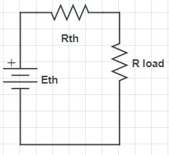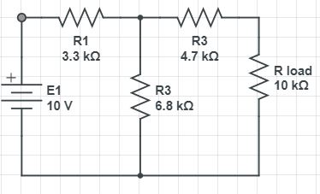

Figure 1 Figure 2

**PROCEDURE**

1. Consider the circuit of Figure 1 using E = 10V, R1 = 3.3 kΩ, R2 = 6.8 kΩ, R3 = 4.7 kΩ and R4 (RLoad) = 10 kΩ. This circuit may be analyzed using standard series-parallel techniques. Determine the voltage across the load, R4, and record it in Table 1.

2. Build the circuit of Figure 1 using the values specified in step one, with RLoad = 10 k. Measure the load voltage and record it in Table 1. Determine and record the deviations. Do not deconstruct the circuit.

3. Determine the theoretical Thevenin voltage of the circuit of Figure 1 by finding the open circuit output voltage. That is, replace the load with an open and calculate the voltage produced between the two open terminals. Record this voltage in Table 2.

4. To calculate the theoretical Thevenin resistance, first remove the load and then replace the source with its internal resistance (ideally, a short). Finally, determine the combination series-parallel resistance as seen from the where the load used to be. Record this resistance in Table 2.

5. The experimental Thevenin voltage maybe determined by measuring the open circuit output voltage. Simply remove the load from the circuit of step one and then replace it with a voltmeter. Record this value in Table 2.

6. There are two methods to measure the experimental Thevenin resistance. For the first method, using the circuit of step one, replace the source with a short. Then replace the load with the ohmmeter. The Thevenin resistance may now be measured directly. Record this value in Table 2.

7. In powered circuits, ohmmeters are not effective while power is applied. An alternate method relies on measuring the effect of the load resistance. Return the voltage source to the circuit, replacing the short from step six. For the load, insert either the decade box or the potentiometer. Adjust this device until the load voltage is half of the open circuit voltage measured in step five and record in Table 2 under “Method 2”. At this point, the load and the Thevenin resistance form a simple series loop as seen in Figure 2. This means that they “see” the same current. If the load exhibits one half of the Thevenin voltage then the other half must be dropped across the Thevenin resistance, that is VRL = VRTH. Consequently, the resistances have the same voltage and current, and therefore must have the same resistance according to Ohm’s Law.

8. Consider the Thevenin equivalent of Figure 2 using the theoretical ETH and RTH from Table 2 along with 10kΩ for the load (RLoad). Calculate the load voltage and record it in Table 3.

9. Build the circuit of Figure 2 using the measured ETH and RTH from Table 2 along with 10kΩ for the load (RLoad). Measure the load voltage and record it in Table 3. Also determine and record the deviation.

**DATA TABLES**

|  |  |  |  |
| --- | --- | --- | --- |
| **RLoad** | **VLoad Theory(V)** | **VLoad Experimental (V)** | **Deviation (%)** |
| 10kΩ | 3.65 | 4.0V | 0.82 |

**Original Circuit (Table 1)**

Table 1

**Thevenized Circuit**

|  |  |  |
| --- | --- | --- |
|  | **Theory** | **Experimental** |
| ETh | 6.73 V | 6.77 V |
| RTh | 6.92kΩ | 6.85 kΩ |

Table 2

|  |  |  |  |
| --- | --- | --- | --- |
| **RLoad** | **VLoad Theory (V)** | **VLoad Experimental (V)** | **Deviation (%)** |
| 10kΩ | 3.9775 | 4.0 | 0.55 |

Table 3

**QUESTIONS & ANSWERS**

**1. Do the load voltages for the original and Thevenized circuits match for both loads? Is it logical that this could be extended to any arbitrary load resistance value?**

Ans: Yes, the load voltage for the original and Thevenized circuits match for both loads. And it is possible to extend the load resistor to any arbitary value. Because, except for the load resistor other properties of the both circuits are equivalent.

**2. Assuming several loads were under consideration, which is faster, analyzing each load with the original circuit of Figure 1 or analyzing each load with the Thevenin equivalent of Figure 2?**

Ans: Analyzing with the Thevenized circuit is faster. Because calculating multiple load resistances in the original circuit is more complicated than Thevenized circuit.

**3. How would the Thevenin equivalent computations change if the original circuit contained more than one voltage source?**

Ans: If the original circuit contains more than one voltage source we have to apply superposition to calculate ETh. There will be no change in calculating RTh.



**Department Of Computer Science & Engineering**

**Electronics Circuit Lab Report**

**Experiment No: 04**

**Experiment Name: Superposition Theorem**

**Course Code: EEE-110**

**Date of Performance : 20-09-17**

**Date of Submission : 08-10-17**

**OBJECTIVE**

The objective of this exercise is to investigate the application of the superposition theorem to multiple DC source circuits in terms of both voltage and current measurements. Power calculations will also be examined.

**THEORY OVERVIEW**

The superposition theorem states that in a linear bilateral multi-source DC circuit, the current through or voltage across any particular element may be determined by considering the contribution of each source independently with the remaining sources replaces with their internal resistance. The contributions are then summed, paying attention to polarities, to find the total value. Superposition cannot be applied to non-linear circuits or non-linear functions such as power.

**EQUIPMENT**

1. Adjustment Dual DC Power Supply
2. Digital Multimeter
3. 3.27 kΩ
4. 6.8 kΩ
5. 4.6 kΩ

**SCHEMATICS**

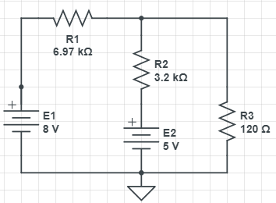

Figure 1

**PROCEDURE**

1. Consider the dual supply circuit of Figure 1 using E1=8V, E2=5V, R1=6.987kΩ, R2=3.2kΩ, R3=120Ω. To find the voltage from node A to the ground, superposition may be used. Each source is considered by itself. First, consider source E1 by assuming that E2 is repeated with its internal resistance (a short). Determine the voltage at node A using standard series-parallel techniques and record it in Table 1. Make sure to indicate the polarity. Repeat the process using E2 while shorting E1. Finally, sum these two voltages and record in Table 1.

2. To verify the superposition theorem, the process may be implemented directly by measuring the contributions. Build the circuit of Figure 1 with the values specified in step 1, however, replace E2 with a short. Do not simply place a shorting wire across source E2. This will overload the power supply.

3. Measure the voltage at node A and record in Table 1. Be sure to note the polarity.

4. Remove the shorting wire and insert sources E2.Also, replace source E1 with a short. Measure the voltage at node A and record in Table 1.Be sure to note the polarity.

5. Remove the shorting wire and re-inserted source E1. Both sources should not be in the circuit. Measure the voltage at node A and record in Table 1. Be sure to note the polarity.

6. Determine and record the deviations between theory and experimental results.

**DATA TABLES**

|  |  |  |  |
| --- | --- | --- | --- |
| **Source** | **VA Theory(V)** | **VA Experimental (V)** | **Deviation (%)** |
| E1 only | 7.687 | 7.78 | 1.06 |
| E2 only | 0.695 | 0.7 | 0.07 |
| E1 & E2 | 8.48 | 8.5 | 0.23 |

Table 1

**QUESTIONS & ANSWERS**

**1) Based on the results of Tables 1, 2 and 3, can superposition be applied successfully to voltage, current and power levels in a DC circuit?**

Ans: Superposition can be applied for voltage and current, but not for power. Power depends on the total current or the total voltage. The equation of power is the second order equation of V or I, so adding power linearly will not give the total power dissipated on some voltage difference.

**2) If one of the sources in Figure 1 had been inserted with the opposite polarity, would there be a significant change in the resulting voltage at node A? Could both the magnitude and polarity change?**

Ans: In superposition theorem, voltage directly depends on polarities of the sources. So if one of the sources connects in opposite polarity, voltage will change. So at node A, magnitude will change and polarity will depend on which source changed its polarity. If we insert E1 in opposite polarity, VA will be 0.17 V and if we insert E2 in opposite polarity, VA will be -0.17 V.

**3) If both of the sources in Figure 1 had been inserted with the opposite polarity, would there be a significant change in the resulting voltage at node A? Could both the magnitude and polarity change?**

Ans: If both sources had been inserted in opposite direction, magnitude would not change, but polarity would be the opposite, VA= – 9.44 V.

**4) Why is it important to note the polarities of the measured voltages and currents?**

Ans: In superposition theorem, the current through, or voltage across, an element in a linear bilateral network, which is equal to the algebraic sum, considering the polarities, of the currents or voltages produced independently by each source. And value of each source requires both magnitude and polarity to be measured.



**Department Of Computer Science & Engineering**

**Electronics Circuit 1 Lab Report**

**Experiment No: 05**

**Experiment Name: Maximum Power Transfer**

**Course Code: EEE-110**

**Date of Performance : 24-09-17**

**Date of Submission : 08-10-17**

**OBJECTIVE**

The objective of this exercise is to determine the conditions under which a load will produce maximum power. Further, the variance of load power and system efficiency will be examined graphically.

**THEORY OVERVIEW**

In order to achieve the maximum load power in a DC circuit, the load resistance must equal the driving resistance, that is, the internal resistance of the source. Any load resistance value above or below this will produce a smaller load power. System efficiency (η) is 50% at the maximum power case. This is because the load and the internal resistance form a basic series loop, and as they have the same value, they must exhibit equal currents and voltages, and hence equal powers. As the load increases in resistance beyond the maximizing value the load voltage will rise, however, the load current will drop by a greater amount yielding a lower load power. Although this is not the maximum load power, this will represent a larger percentage of total power produced, and thus a greater efficiency ( the ratio of load power to total power ).

**Equipment:**

1. Adjustable DC Power Supply
2. Digital Multimeter
3. 10 kΩ
4. Resistance Decade Box

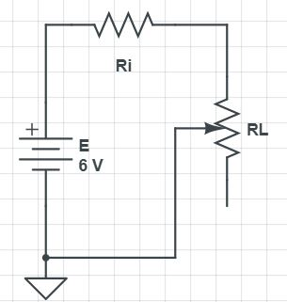**SCHEMATICS**

Figure 1

**Procedure:**

1. Consider the simple series circuit of figure 12.1 using E=10 volts and Ri=3.3k. Ri forms a simple voltage divider with RL. The power in the load is VL²/RL and the total circuit power is E²(Ri + RL). The larger the value of RL, the greater the load voltage, however, this does not mean that very large values of RL will produce maximum load power due to the division by RL. That is, at some point VL² will grow more slowly than RL itself. This crossover point should occur when RL is equal to Ri. Further, note that as RL increases, total circuit power decreases due to increasing total resistance. This should lead to an increase in efficiency. An alternate way of looking at the efficiency question is to note that as RL increases, circuit current decreases. As power is directly proportional to the square of current, as RL increases the power in Ri must decrease leaving a larger percentage of total power going to RL.

2. Using RL=30, compute the expected values for load voltage, load power, total power and efficiency, and record them in table 12.1. Repeat for the remaining RL values in the table. For the middle entry labeled as Actual, insert the measured value of the 3.3k used for Ri.

3. Build the circuit of figure 12.1 using E=10 volts and Ri=3.3k. Use the decade box for RL and set it to 30 Ohms. Measure the load voltage and record it in table 12.2. Repeat for the remaining resistor values in the table.

4. Create two plots of the load power versus the load resistance value using the data from the two tables, one for theoretical, one for experimental. For best results make sure that the horizontal axis (RL) uses a log scaling instead of linear.

5. Create two plots of the efficiency versus the load resistance value using the data from the two tables, one for theoretical, one for experimental. For best results make sure that the horizontal axis (RL) uses a log scaling instead of linear.

**DATA TABLES**

|  |  |  |  |  |
| --- | --- | --- | --- | --- |
| **RL** (kΩ) | **VL** (V) | **PL** (mW) | **PT** (mW) | **η** (%) |
| 2 | 0.85 | 0.36 | 3.00 | 0.12 |
| 4 | 1.48 | 0.55 | 2.571 | 0.21 |
| 6 | 2.08 | 0.721 | 2.25 | 0.32 |
| 8 | 2.53 | 0.80 | 2.00 | 0.40 |
| 10 | 2.834 | 0.826 | 1.80 | 0.458 |
| 12 | 3.15 | 0.808 | 1.63 | 0.495 |
| 14 | 3.36 | 0.806 | 1.50 | 0.537 |
| 20 | 3.88 | 0.752 | 1.20 | 0.626 |

Table 1

**QUESTIONS & ANSWERS**

**1) At what point does maximum load power occur?**

Ans: When Ri is equal to RL then maximum power occurs.

**2) At what point does maximum total power occur**?

Ans: When RL is zero then maximum total power occurs.

**3) At what point does maximum efficiency occur?**

Ans: When RL is much greater than RI ,which means RL>> RI then maximum efficiency occurs.

**4) Is it safe to assume that generation of maximum load power is always a desired goal? Why/why not?**

Ans: No. Because sometimes it is desired to have maximum efficiency and sometimes maximum power.



**Department Of Computer Science & Engineering**

**Electronics Circuit 1 Lab Report**

**Experiment No: 06**

**Experiment Name: Mesh Analysis**

**Course Code: EEE-110**

**Date of Performance : 24-09-17**

**Date of Submission : 08-10-17**

**OBJECTIVE**

The study of mesh analysis is the objective of this exercise, specifically its usage in multi-source DC circuits. Its application to finding circuit currents and voltages will be investigated.

**THEORY OVERVIEW**

Multi-source DC circuits may be analyzed using a mesh current technique. The process involves identifying a minimum number of small loops such that every component exists in at least one loop. Kirchhoff’s voltage law is then applied to each loop. The loop currents are referred to as mesh currents as each current interlocks or meshes with the surrounding loop currents. As a result there will be a set of simultaneous equations created, an unknown mesh current for each loop. Once the mesh currents are determined, various branch currents and component voltages may be derived.

**EQUIPMENT**

(1) Adjustable DC Power Supply

(2) Digital Multimeter

(3) 1 kΩ

(4) 470 Ω

(5) 680 Ω

(6) 220 Ω

(7) 1 kΩ

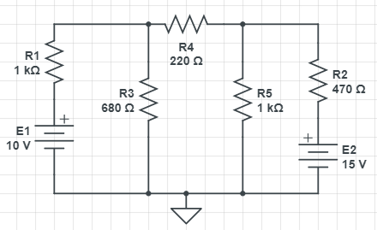**SCHEMATICS**

Figure 1

**PROCEDURE**

1. Consider the dual supply circuit of Figure 13.1 using E1=10 volts, E2=15 volts, R1=4.7k, R2=6.8k and R3=10k. To find the voltage from node A to ground, mesh analysis may be used. This circuit may be described via two mesh currents, loop 1 formed with E1, R1, R2 and E2, and loop 2 formed with E2, R2 and R3. Note that these mesh currents are the currents flowing through R1 and R3 respectively.

2. Using KVL, write the loop expressions for these two loops and then solve to find the mesh currents. Note that the third branch current (that of R2) is the combination of the mesh currents and that the voltage node A can be determined using the second mesh current and Ohm’s law. Compute these values and record them in table 13.1.

3. Build the circuit of Figure 13.1 using the values specified in step one. Measure the three branch currents and the voltage at node A and record in table 13.1. Be sure to note the directions and polarities. Finally, determine and record the deviations in table 13.1.

4. Consider the dual supply circuit of Figure 13.2 using E1=10 volts, E2=15 volts, R1=4.7k, R2=6.8k, R3=10k, R4=22k, R5=33k. This circuit will require three loops to describe fully. This means that there will be three mesh currents in spite of the fact that there are five branch currents. The three mesh currents correspond to the currents through R1, R2 and R4.

5. Using KVL, write the loop expressions for these loops and then solve to find the mesh currents. Note that the voltages at node A and B can be determined using the mesh currents and Ohm’s law. Compute these values and record them in table 13.2.

6. Build the circuit of Figure 13.2 using the values specified in step four. Measure the three mesh currents and the voltages in node A, node B and from node A to B, and record in table 13.2. Be sure to note directions and polarities. Finally, determine and record the deviations in table 13.2.

**DATA TABLES**

|  |  |  |  |
| --- | --- | --- | --- |
| **Parameter** | **Theory** | **Experimental** | **Deviation (%)** |
| IR1 | 0.029 A | 0.003 A | 89.655 |
| IR2 | 0.016 A | 0.015 A | 6.25 |
| IR4 | 0.058 A | 0.005 A | 91.37 |
| VA | 6.45 V | 6.7 V | 3.87 |
| VB | 7.89 V | 8.2 V | 3.92 |
| VAB | 1.23 V | 1.46 V | 18.699 |

Table 1

**Questions & Answers**

**1) Do the polarities of the sources in Figure 1 matter as to the resulting currents? Will the magnitudes of the currents be the same if one or both sources have an inverted polarity?**

**Ans.**

* Yes, polarities do matters at resulting currents.
* No, magnitude will change.

**2) In both circuits of this exercise the negative terminals of the sources are connected to ground. Is this a requirement for mesh analysis? What would happen to the mesh currents if the positions of E1 and R1 in Figure 1 were swapped?**

**Ans.**

* No.
* The mesh current will be the same as before.

**3) If branch current analysis (BCA) was applied to the circuit of Figure 2, how many unknown currents would have to be analyzed and how many equations would be needed? How does this compare to mesh analysis?**

**Ans.**

* 5 unknown currents would have to be analyzed and 5 equations would be needed.
* If we use mesh analysis, we would have to analyze 3 unknown currents and 3 equations. So calculations will be simple.

**4) The circuits of Figures 1 and 2 had been analyzed previously in the Superposition Theorem exercise. How do the results of this exercise compare to the earlier results? Should the resulting currents and voltages be identical? If not, what sort of things might affect the outcome?**

**Ans.** Both results are same. Yes, resulting currents and voltages are identical.